Assignment 3
Docker / Minikube

Q.1. Login as dev1 user. Open terminal and perform following steps
cd
mkdir py-app
cd py-app
nano app1.py
Type following code in this file.
Num1 = int(input(“Enter Number1: “))
Num2 = int(input(“Enter Number2: “))

Result1 = Num1 + Num2
Result2 = Num1 * Num2
print(“The result of addition is: “, Result1)
print(“The result of multiplication is:, Result2)

Save the file.
Create the dockerfile.
nano dockerfile
Type following
FROM ubuntu
RUN apt update -y
RUN apt install python3 -y
RUN mkdir /app1
COPY app1.py /app1/
CMD [ “/bin/python3”, “/app1/app1.py” ]
Save the file.
Build image
docker build -t py-app:v1 .

Once the build process is over execute the container
docker run --rm -ti py-app:v1

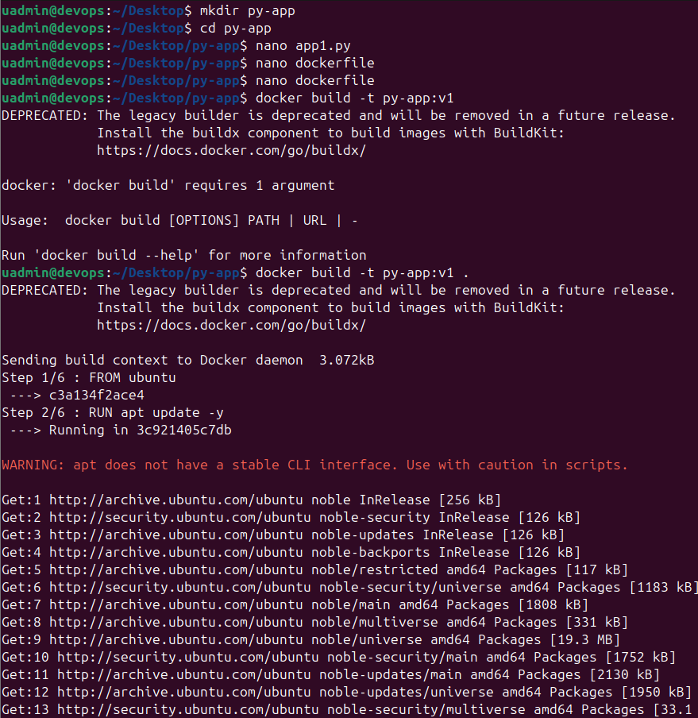
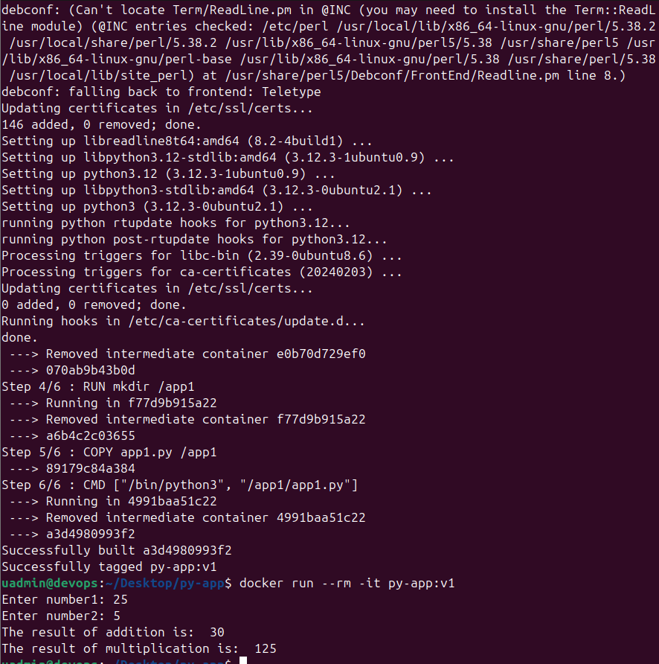

Q.2. Create a directory. Go to that directory.
mkdir web1
cd web1
Create your index.html file that will display your name and PRN number.
Create a dockerfile.
nano dockerfile

Add following to the file.

FROM httpd
COPY index.html /usr/local/apache2/htdocs/

Save the file. Use docker build command to build your application image.

docker build -t webapp1 . # Don’t forget dot at the end.

Now run the container using above image and verify.

docker run --name web3 -p 8000:80 -d webapp1

Now go to the browser and check by typing http://localhost:8000
Create account on Docker Hub. Create repository and push the image to your repository.

